Background
Living Links is a collaborative initiative with a vision to create “An urban web of green where people and nature connect”. By linking up the many parks, reserves and other natural places across Melbourne’s south-east, it aims to make the region a world-class urban ecosystem. This will improve habitat for wildlife and make it easier for people to connect with nature as part of their daily lives.

Bringing this vision to reality requires many people and organisations to be involved. Living Links is a collaboration between Councils, Government agencies and community/interest groups who are all working together to achieve bigger and better outcomes than if they worked alone.
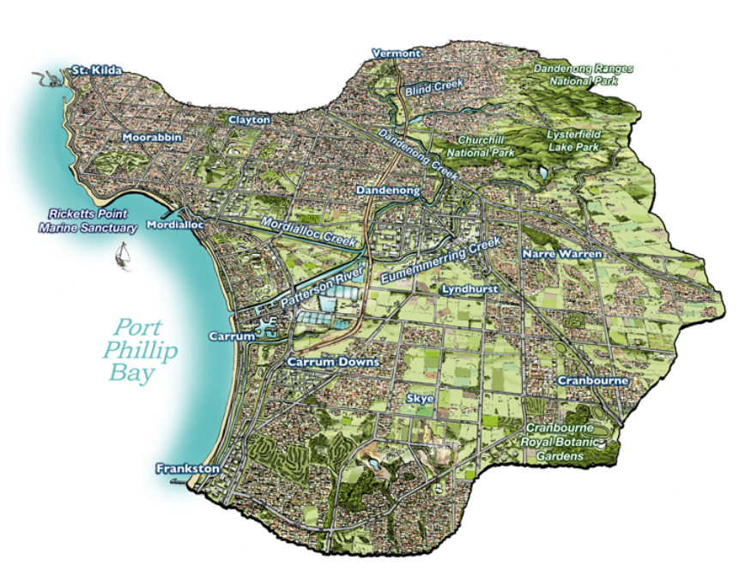
The Region
The Living Links program covers roughly 85,500 ha in Melbourne’s south-east, which is largely defined by the Dandenong Creek catchment. It extends from the foothills of the Dandenong Ranges in the north-east, across to St Kilda in the north-west, and along the Port Phillip Bay coastline down to Frankston in the south. In addition to Melbourne’s renowned bayside beaches, natural treasures include Braeside Park, Lysterfield Lake, Jells Park, the Dandenong Valley Parklands and the Royal Botanic Gardens Cranbourne. Urban areas cover around 60 per cent of the catchment, while 30 per cent is used for agriculture and about 10 per cent retains natural vegetation cover.

This Living Links region is a vibrant hub of economic, cultural and recreational activity, supporting thriving business and industrial sectors that are among the strongest in Australia. It is home to a diverse population of around 1.5 million people, and infrastructure is developing rapidly to keep pace with the area’s growing population. Living Links is working to retain and protect the natural values of the region in the face of continuing development, to enable this region to continue being one of the most liveable parts of one of the world’s most liveable cities.

What is the Living Links Ambassador Schools Program?
Living Links supports one primary or secondary school located within the Dandenong Creek Catchment to undertake a project relating to the Living Links program vision of “Creating a web of green spaces where people and nature connect”.

The objectives of the Living Links Ambassador School Program are:
- Create long-lasting connections of students to the importance of urban environments
- Allow students to explore local environmental issues affecting their school and local community
- Promoting innovative learning that fosters environmental stewardship
- Promoting an awareness of the Living Links Program

Examples of projects may include:

- Revegetation and habitat enhancement
- Urban Ecology
- Litter
- Urban Greening
- Connecting people to nature
- Water Quality
- Community engagement
- Recreation
- Waterway health

What does the Ambassador School receive?
- A $2,000 grant to develop and implement their project including materials and equipment that maybe needed
- A Living Links Ambassador Schools Sign to display
The Process
Date | Action
February 2023 | Applications open
27 March 2023 | Applications close
April 2023 | Applications assessed by Project Working Group and provide a recommendation for a preferred project to the Living Links Committee.
24 April 2023 | Successful school notified & commences project in Term 2
December 2023 | School Presents project to Living Links Committee  Awarding of Living Links Ambassador School Program Sign
Further Information
For further information about the Living Links Ambassador Schools program visit www.livinglinks.com.au or contact:

Samantha Bradley
Living Links Coordinator
samantha.bradley@melbournewater.com.au
Submitting Your Application
Applications are due by March 27 2023. When completed please email this Application Form to: samantha.bradley@melbournewater.com.au

School details
School name:
Postal address:
Suburb/postcode:
Contact person:
Contact phone number:
Contact mobile number:
Contact email:
ABN number:
GST registered?

Project summary
Project Title (10 words max)
Project Description (500 words max)
How will your project help deliver Living Links objectives?
How will your school continue to be a Living Links Ambassador once the project is complete?
Where will the project be located?
Do you have permission of the land manager? (please attach a letter of support from the land manager if required)

